TORABERU

Project on Travel Guide

Made by:

Avinash Kumar

Abhishek Bulbule

S.Y.B.B.A(C.A) Sem IV

GitHub Repository



Acknowledgement

A successful project is the result of a good team work which consists of not only the partners who put in their long and hard work but also those who have guided the project throughout the development cycle.

I would like to express my sincere and deep gratitude towards my internal project guide Mrs. Padma Nene for her valuable supervision, guidance and suggestions.

I am also thankful to all the faculty members who supported me throughout the completion of my project.

Introduction

* The project is a system that guides the tourists to visit the popular places around the Maharashtra. This will give exposure to tourist to the culture and tradition of the state.
* This system will also help find the place to visit during the unlock after the pandemic as many of the place will not be open for the regular visit.
* Image gallery will be provided.

Proposed system

* To create a system that helps the tourists from different place who would like to visit Maharashtra as a tourist destination.
* Provide basic info regarding different places that are present in different cities within the state like visiting hours, average visiting time, entry fees etc.
* Services provided by the system
* Tourist place information
* Basic information
* Map to the place
* Photo gallery

Objectives

The system will provide a rich and user-friendly user interface to the user to explore the places that are present in Maharashtra that they walt to visit.

The site must be mobile optimised that is have a good look even in mobile/smart phones regardless of the orientation of the device which may be the landscape or portrait.

Also, the system should be able to accept updates when or if needed by the user or the administration.

System Requirements

Minimum hardware requirement:

* Intel Pentium 4 / AMD Athlon 64 Newark / ARM based CPU
* 2 GB ram
* 2GB storage (1GB for mobile use i.e., ARM)

Software requirements:

* Latest version of Windows /Mac OS /Linux /Android /Harmony OS /iOS / iPad OS is recommended.
* Web browser with support to ECMA Script 6.

System design

Entity Relationship Diagram

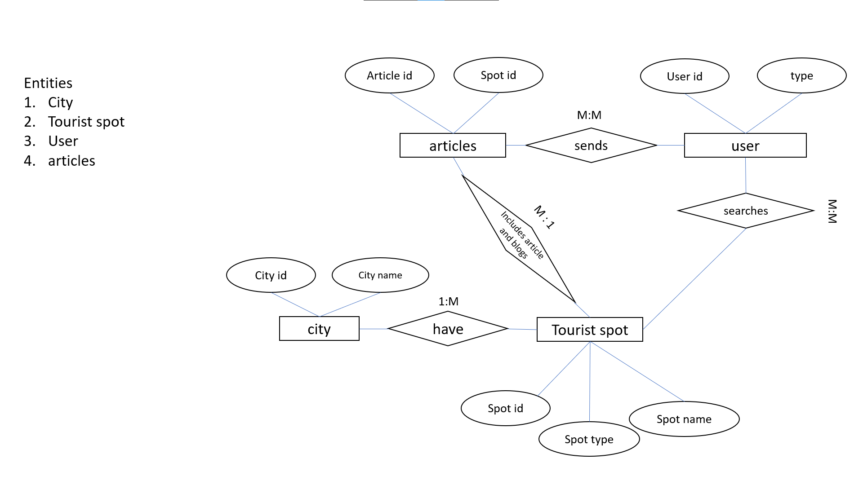

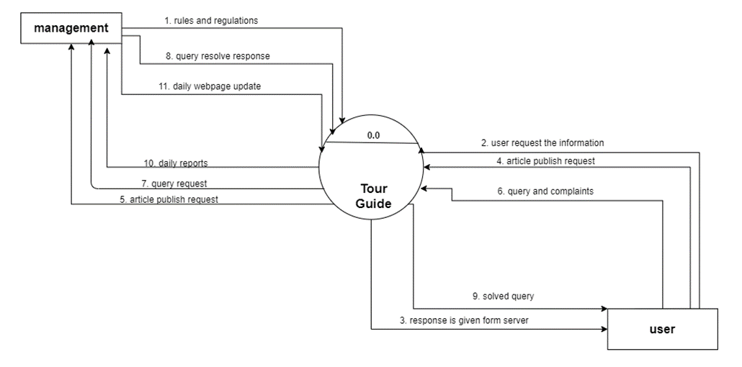Context Level Diagram

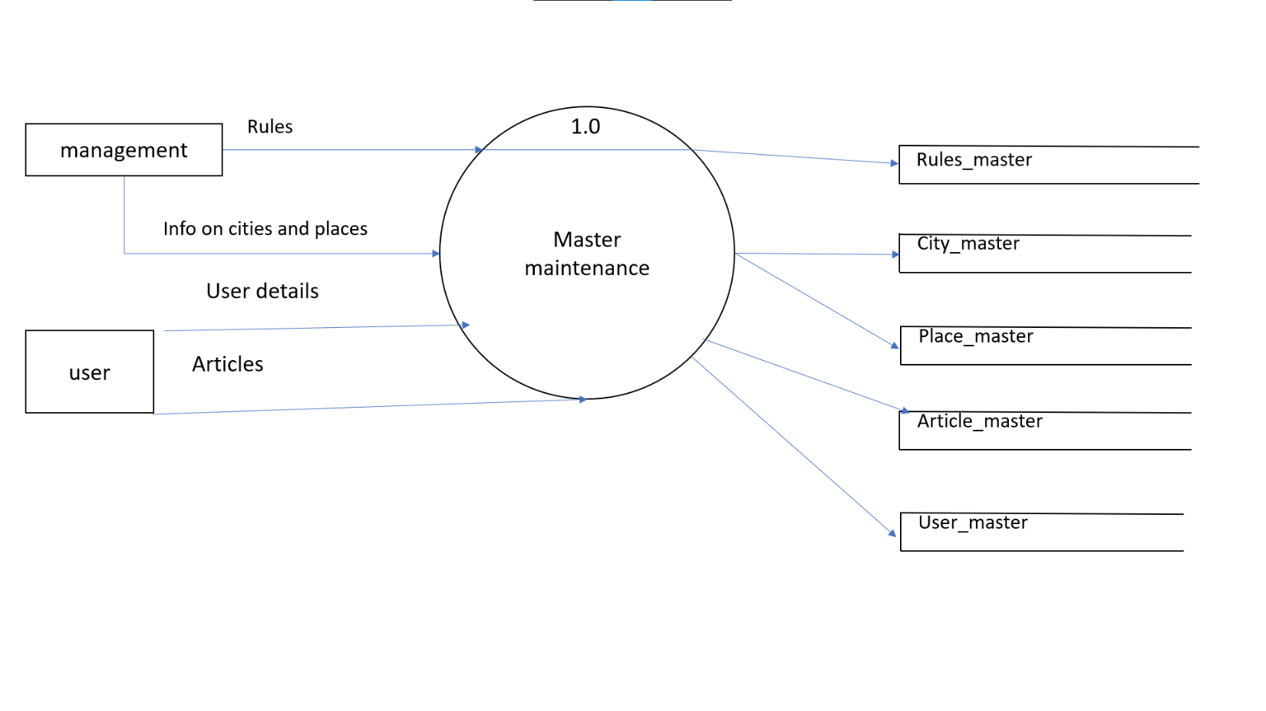Data Flow Diagram

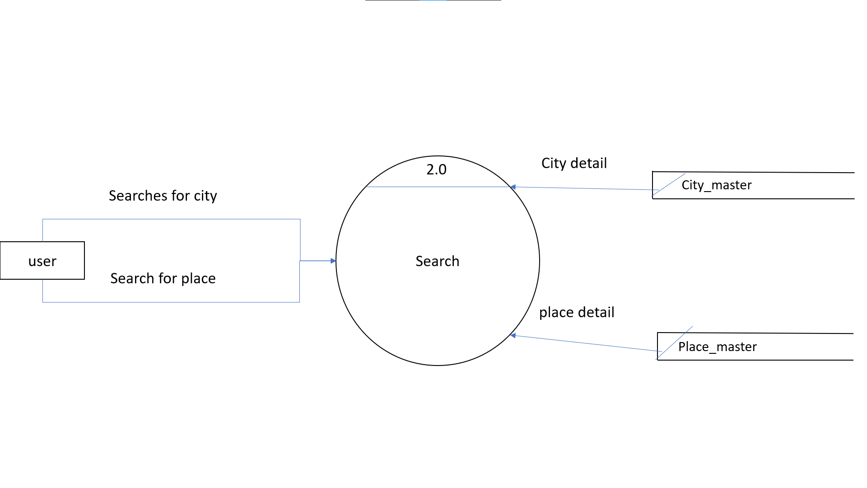

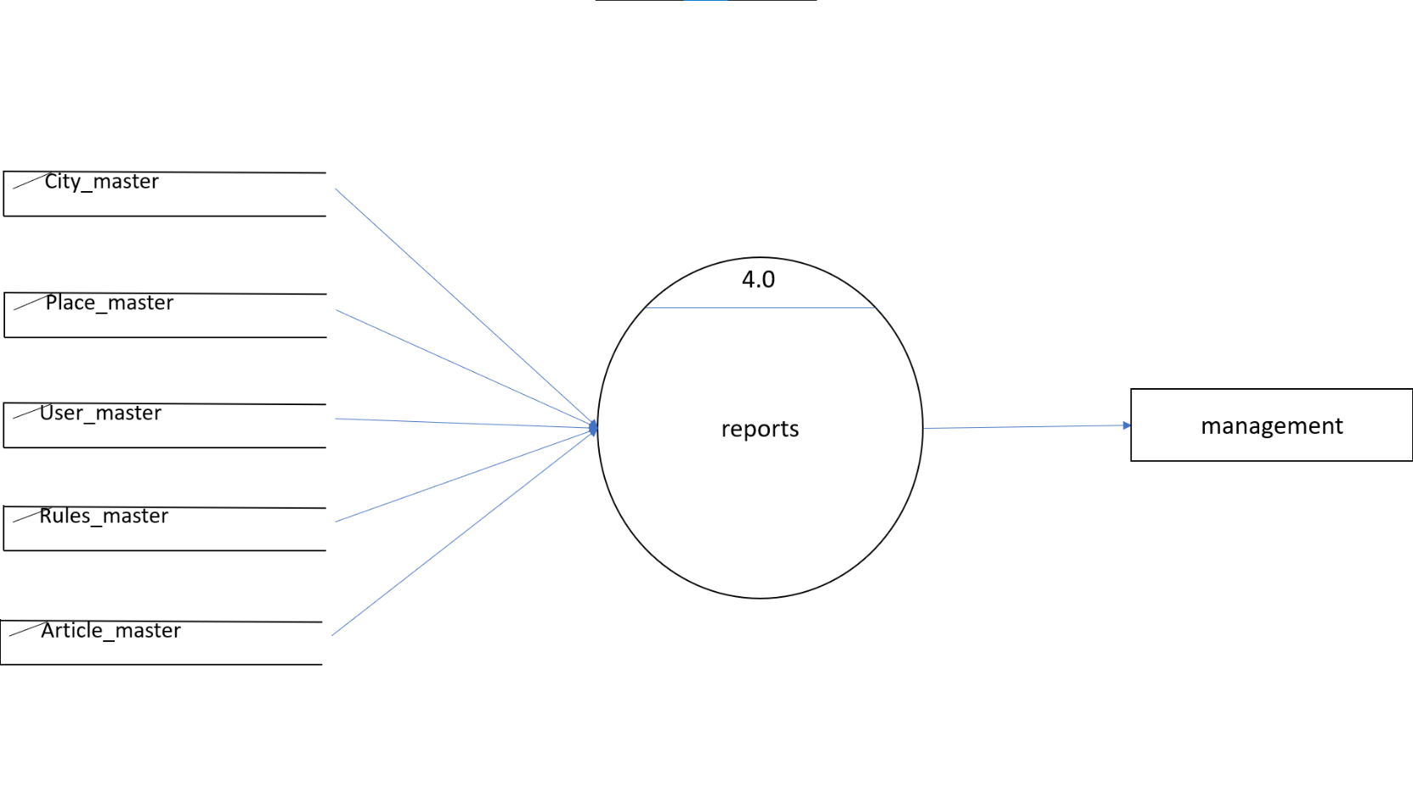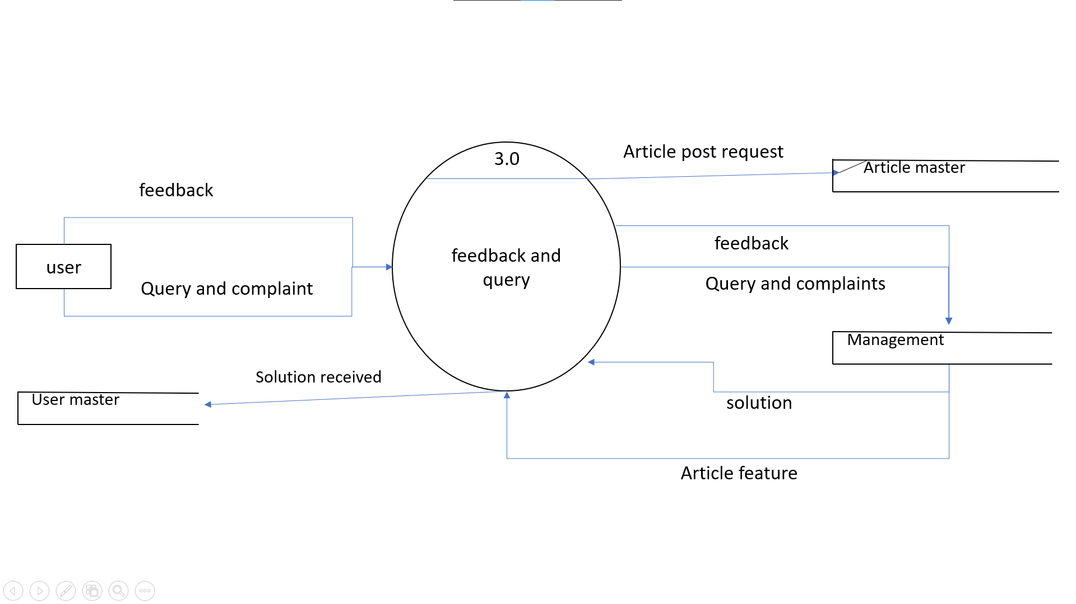

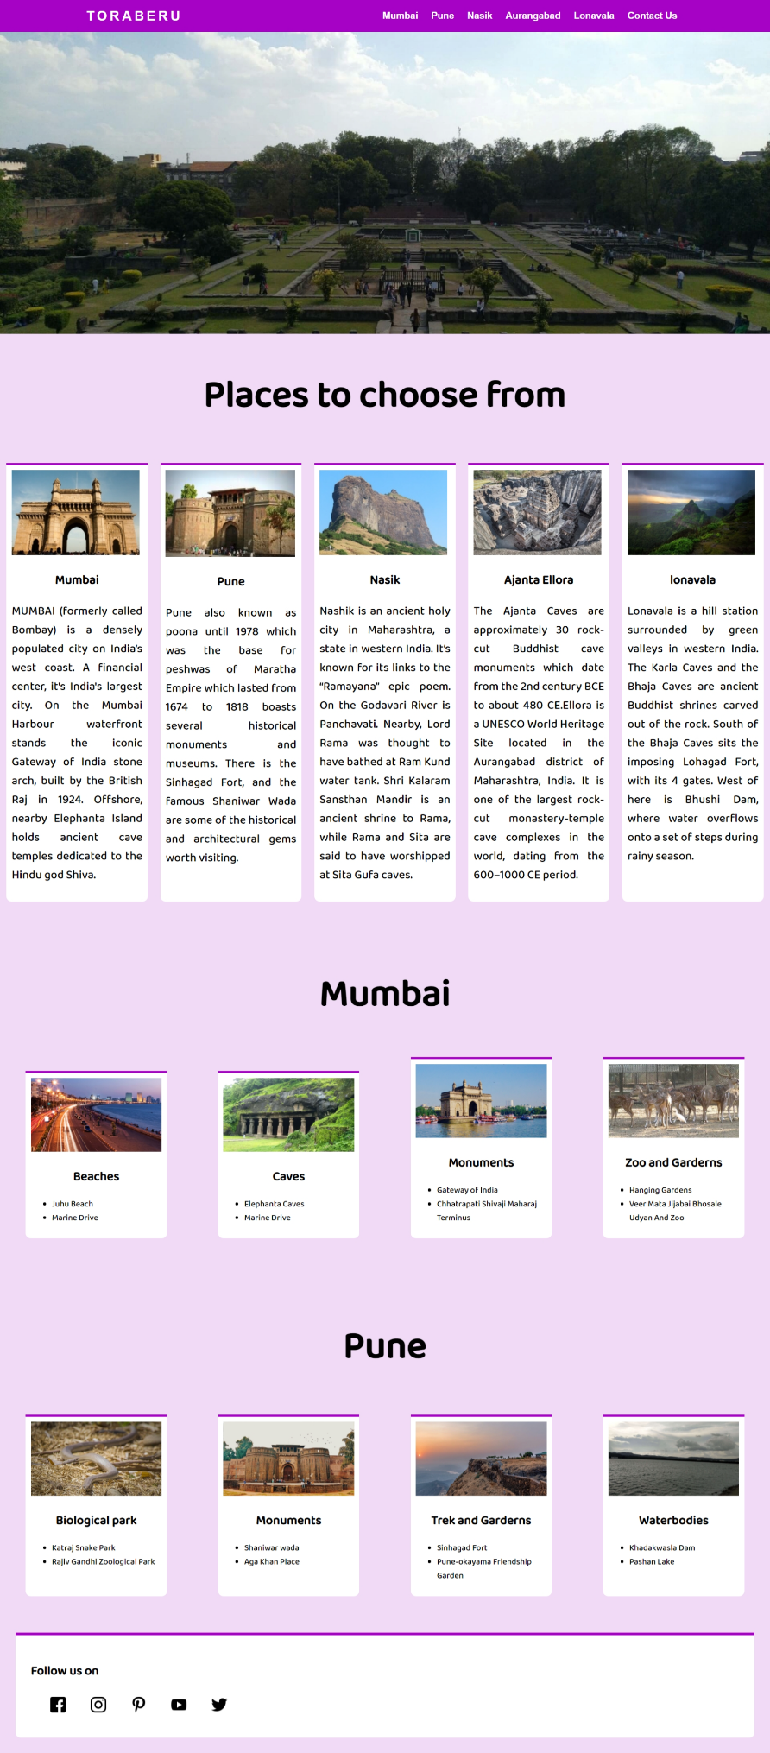Design

Home Page

Spot page gallery

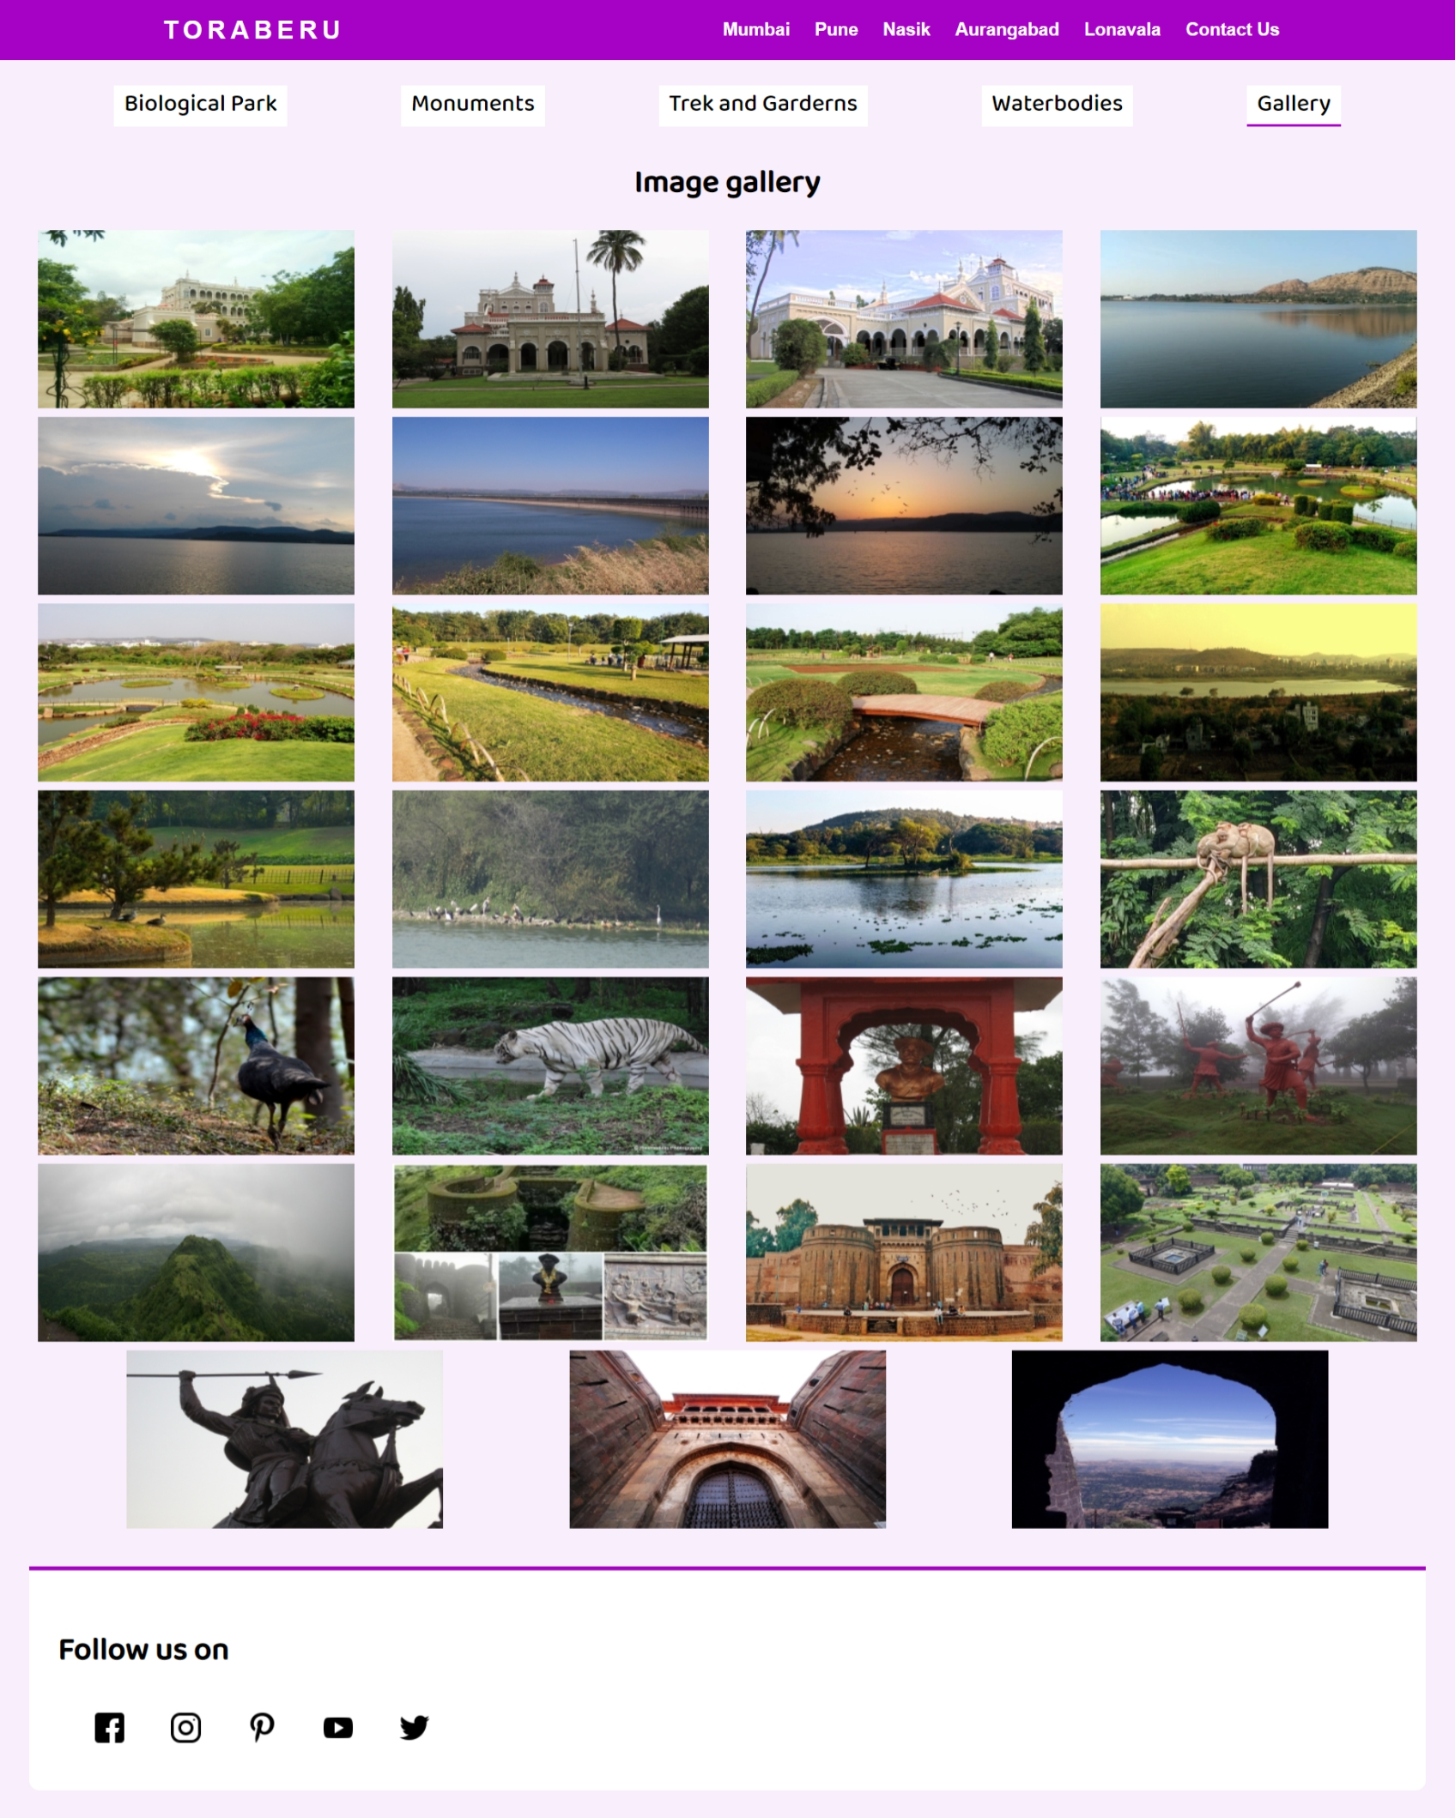

Spot page